Open New Notepad document:
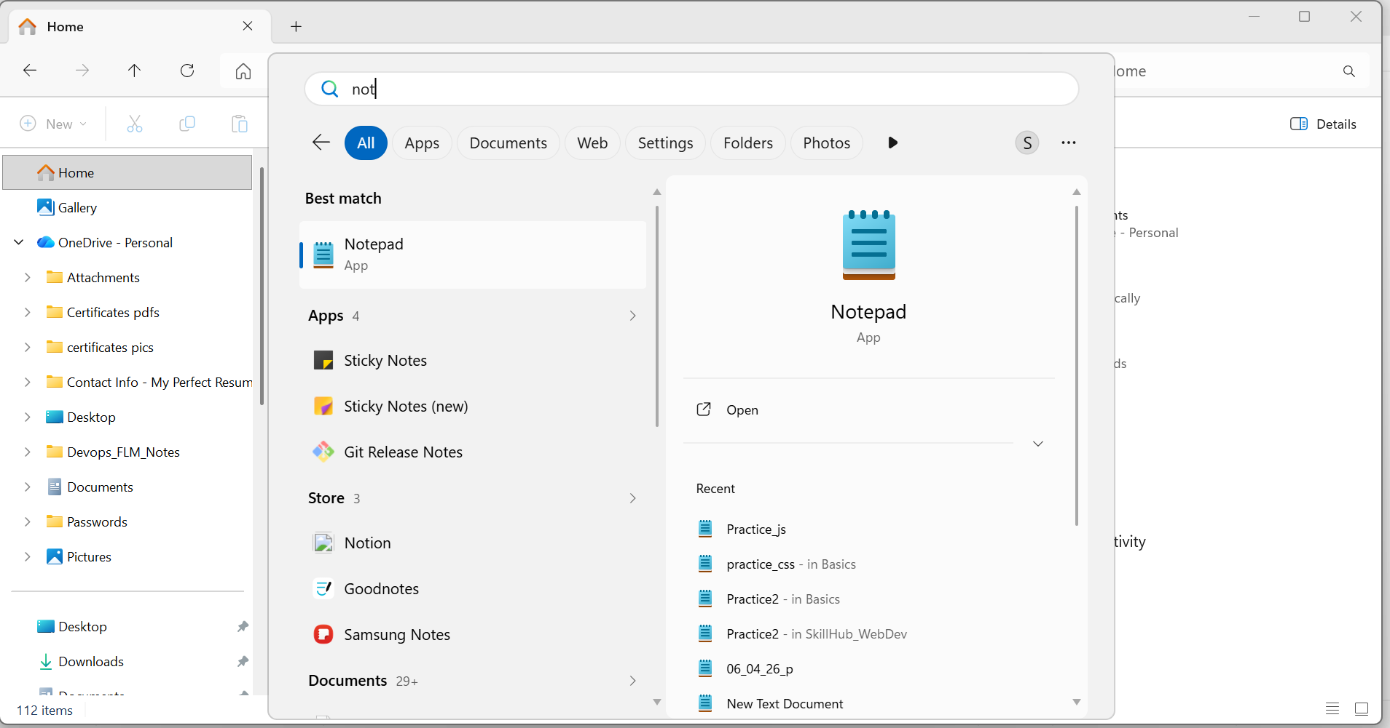
Click on plus(+) icon

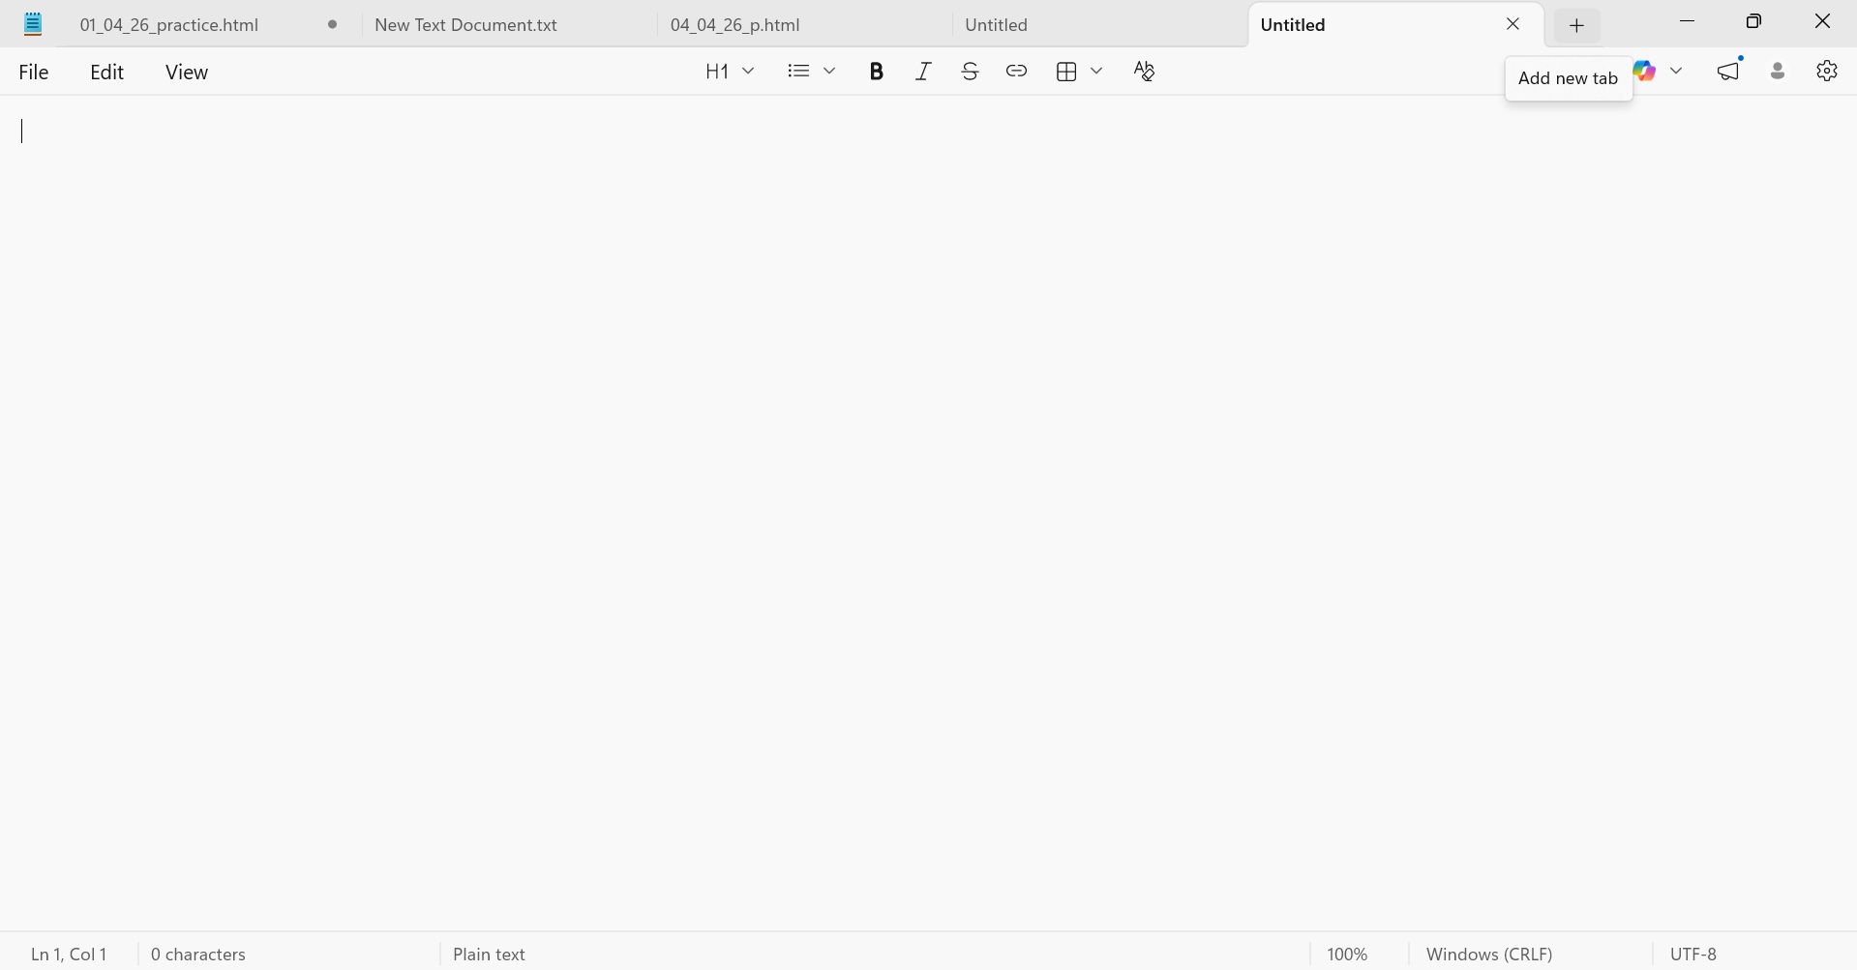

Click on save
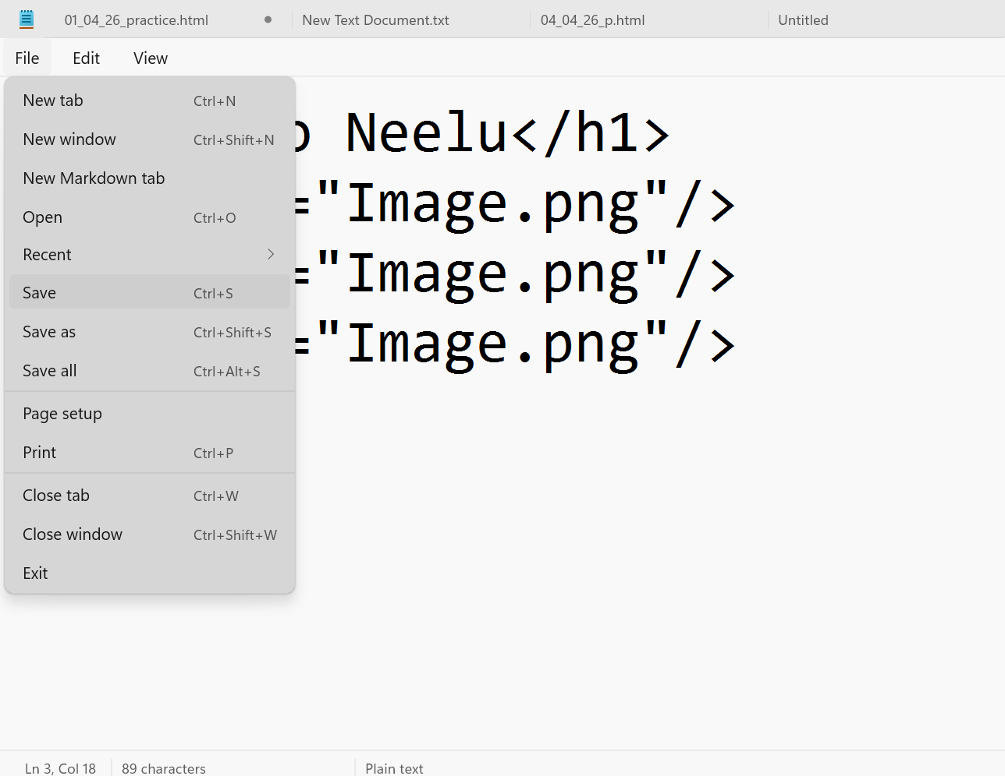

Select desktop
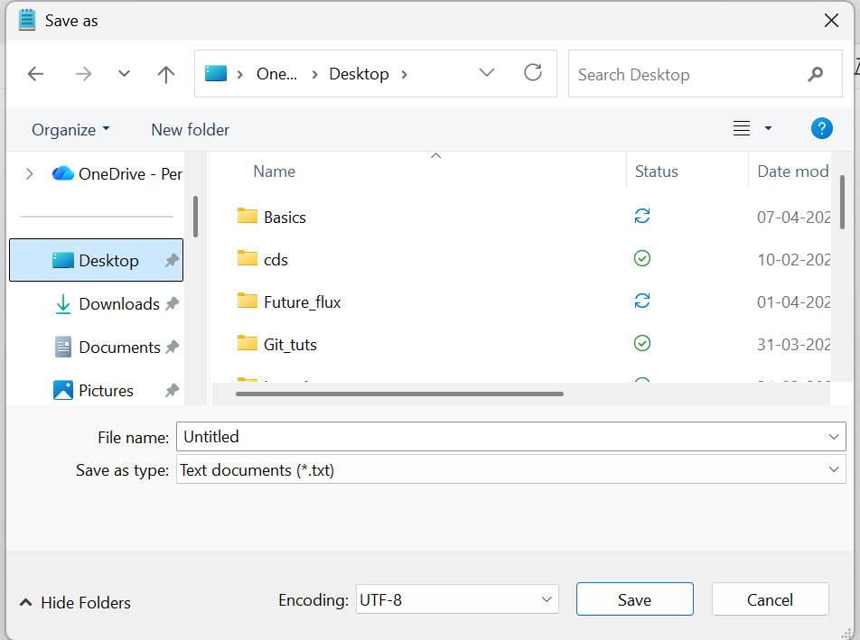
Select folder name (ex:Basics):
Click on open:
Select all files in dropdown
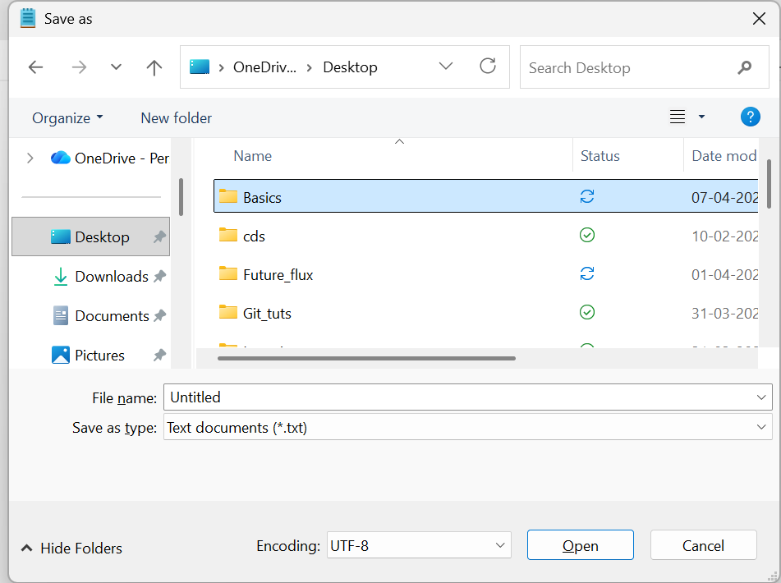
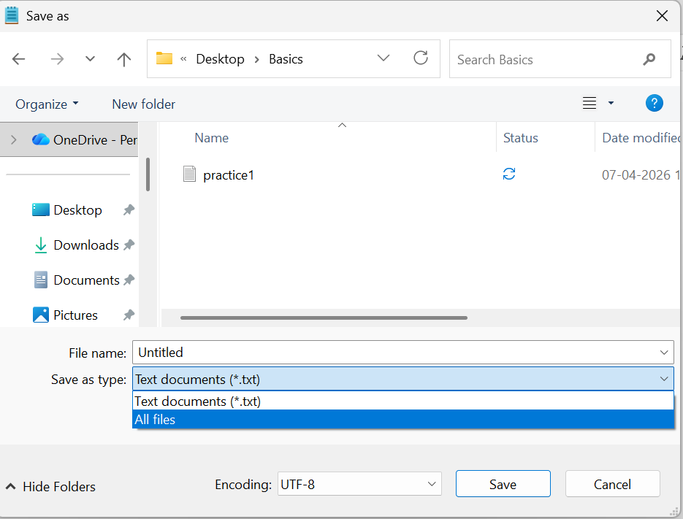
Enter file Name :
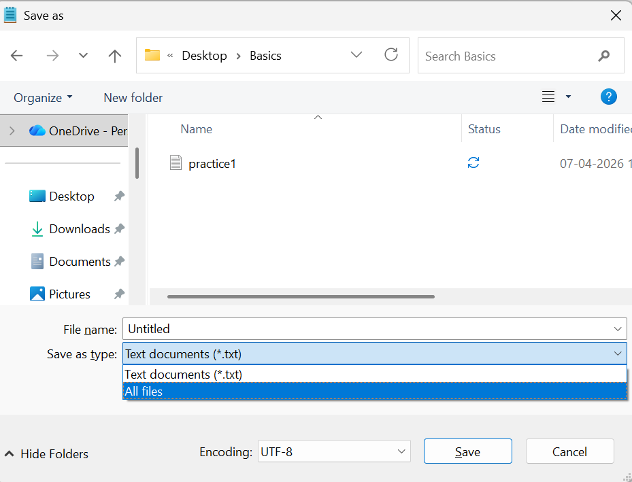
filename.html xxxx.html
enter Name of file
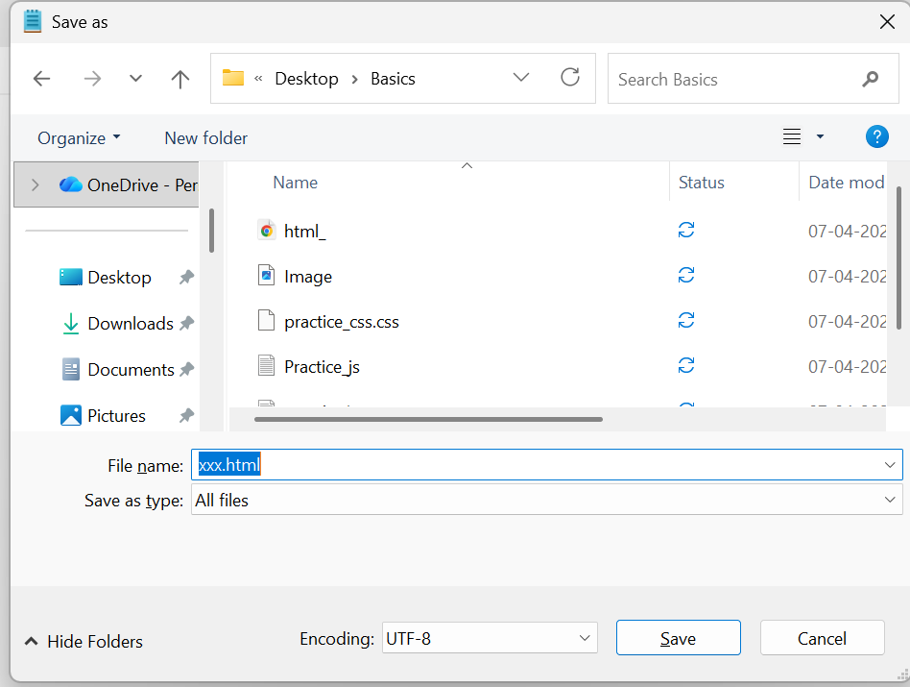
Click on save
Go folder and select on .heml file Right click on mouse
Open with Note pad:
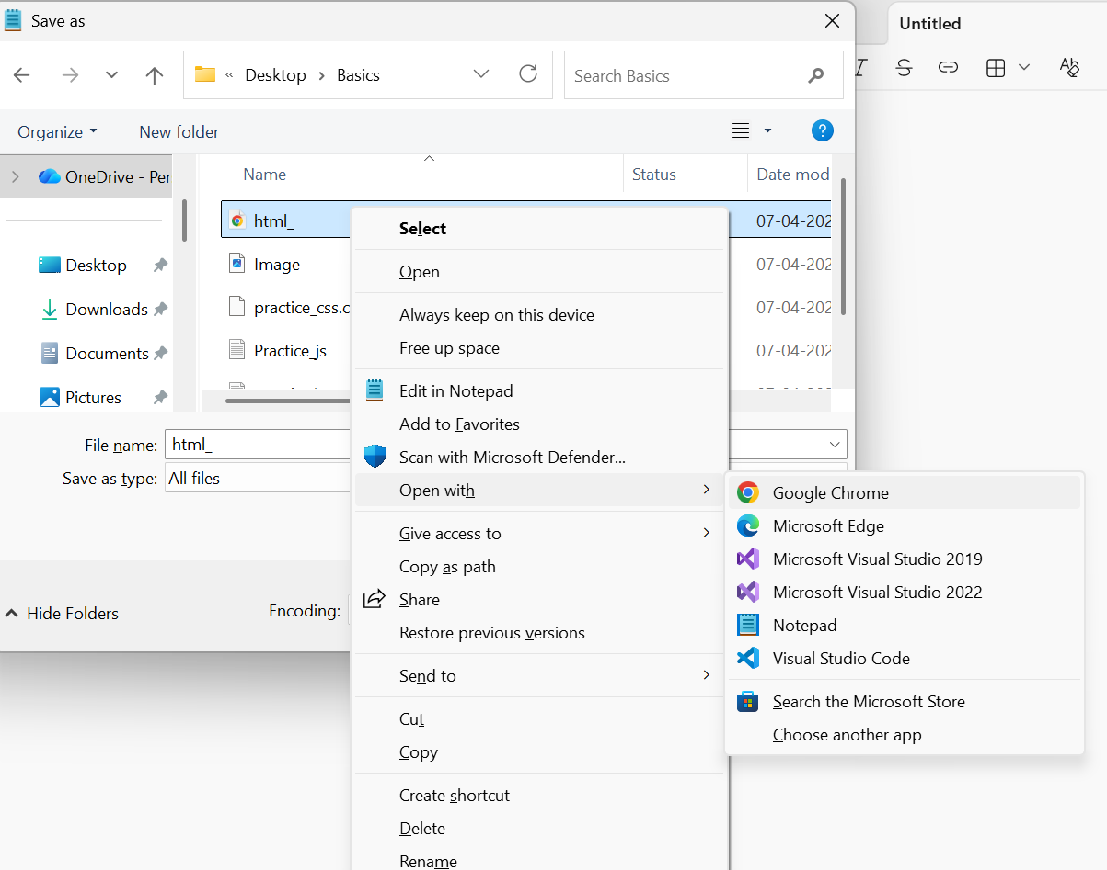

Select fileright clickopen withGoogle chrome/Notepad(for Browser)

.html/.css/.js file extension
To save Image screenshot in Desktop:
Search for snipping tool :
Open snap and save as file path(open your folder and save)
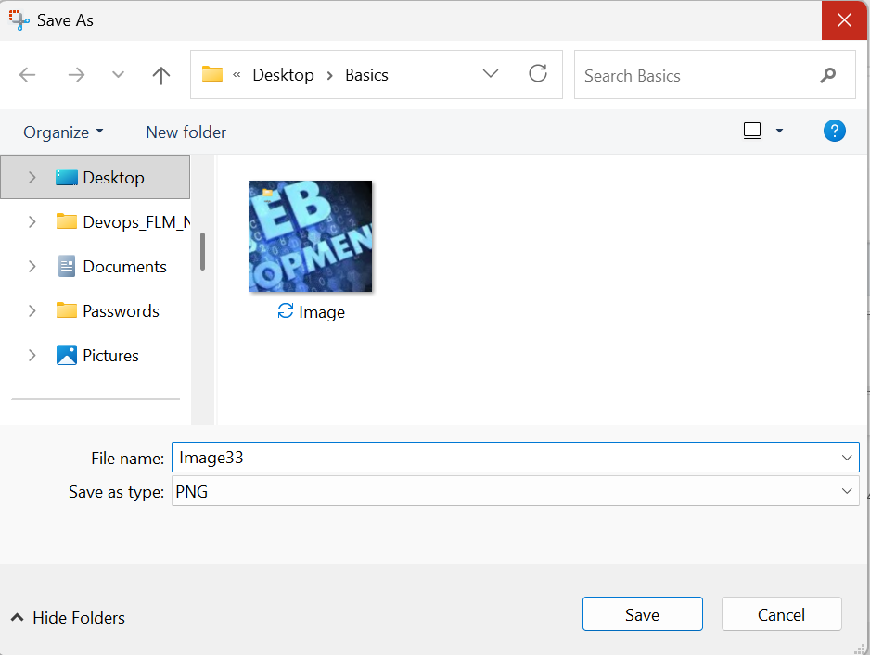

Click on save
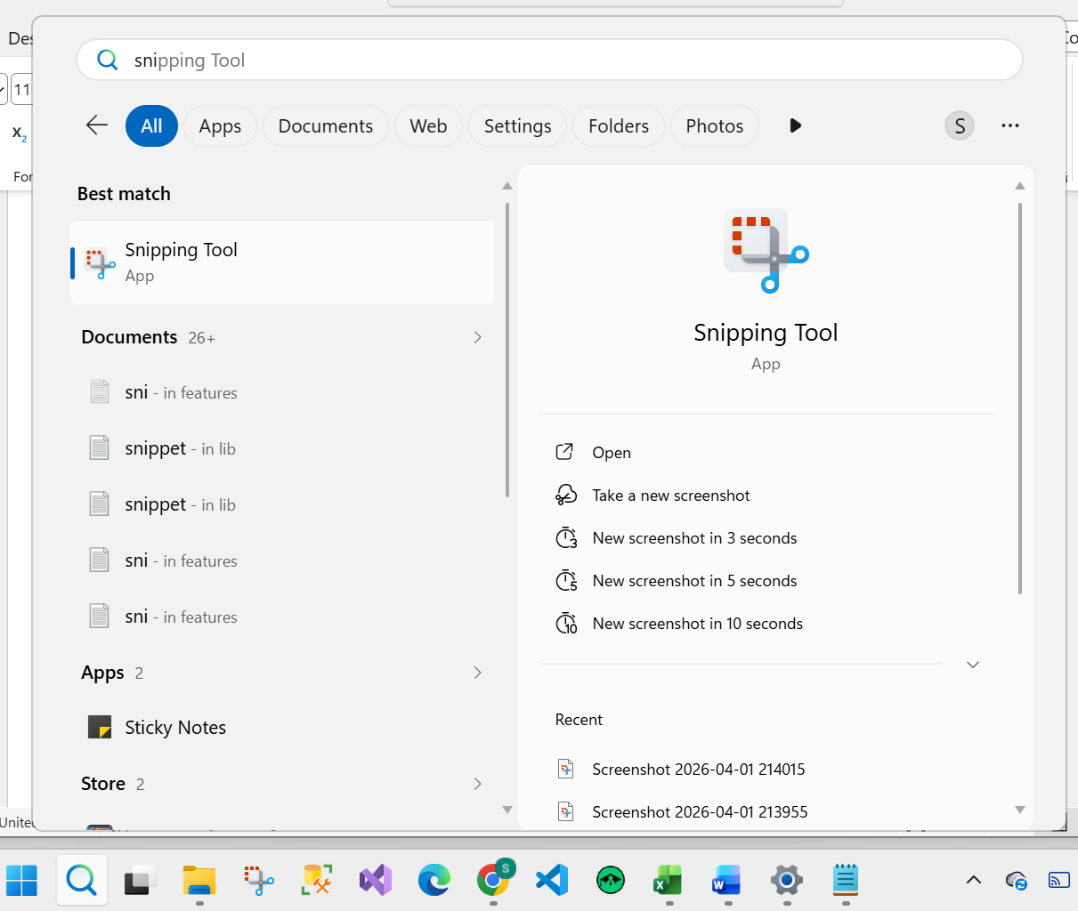
Click on snipping toolclick on new
